Paper 4:
Severity Calculation Results
Table 1: Training Results
Table X: Performance Evaluation of the Proposed U-Net++ with EfficientNet B0 Model
Class Name | Dataset Split | Dice Score | IoU | Accuracy | Precision | Recall | HD95 (pixels)
Corrugation of Rails | Training | 0.8592 | 0.7548 | 0.9649 | 0.6811 | 0.8530 | 43.31
Corrugation of Rails | Validation | 0.7531 | 0.6121 | 0.9649 | 0.6811 | 0.8530 | 76.92
Corrugation of Rails | Test | 0.8045 | 0.6774 | 0.9653 | 0.7902 | 0.8295 | 43.67
Hogging of Rails | Training | 0.7914 | 0.6566 | 0.9757 | 0.8451 | 0.7134 | 66.52
Hogging of Rails | Validation | 0.7680 | 0.6281 | 0.9757 | 0.8451 | 0.7134 | 69.05
Hogging of Rails | Test | 0.7862 | 0.6484 | 0.9774 | 0.7523 | 0.8389 | 70.99
Rail End Batter | Training | 0.7736 | 0.6460 | 0.9833 | 0.6733 | 0.7101 | 54.75
Rail End Batter | Validation | 0.6751 | 0.5287 | 0.9833 | 0.6733 | 0.7101 | 44.64
Rail End Batter | Test | 0.7168 | 0.5818 | 0.9897 | 0.7385 | 0.7186 | 40.69
Rail Wear | Training | 0.7921 | 0.6646 | 0.9695 | 0.8238 | 0.7811 | 100.33
Rail Wear | Validation | 0.7537 | 0.6372 | 0.9475 | 0.7194 | 0.8223 | 64.52
Rail Wear | Test | 0.8439 | 0.7409 | 0.9805 | 0.8688 | 0.8351 | 31.61
Scabbing of Rails | Training | 0.7514 | 0.6088 | 0.9600 | 0.7815 | 0.7487 | 99.00
Scabbing of Rails | Validation | 0.7017 | 0.5496 | 0.9415 | 0.7699 | 0.6746 | 100.00
Scabbing of Rails | Test | 0.8439 | 0.7409 | 0.9805 | 0.8688 | 0.8351 | 31.61
Shelling and Black Spots | Training | 0.9229 | 0.8587 | 0.9592 | 0.9076 | 0.9255 | 77.28
Shelling and Black Spots | Validation | 0.8922 | 0.8103 | 0.9543 | 0.8926 | 0.8959 | 63.18
Shelling and Black Spots | Test | 0.8978 | 0.8180 | 0.9560 | 0.8904 | 0.9088 | 56.92
Wheel Burns | Training | 0.8362 | 0.7213 | 0.9795 | 0.8828 | 0.8045 | 63.30
Wheel Burns | Validation | 0.7614 | 0.6405 | 0.9719 | 0.8130 | 0.7275 | 54.57
Wheel Burns | Test | 0.7729 | 0.6366 | 0.9748 | 0.9097 | 0.6835 | 40.90

Table 2: Run Time Analysis : UNet++ with Efficient B0 Model

Class Name | Total training time | Avg epoch time
Corrugation of Rails | 695.5291919708252 | 34.776205885410306
Hogging of Rails | 730.214586019516 | 36.51029469966888
Rail End Batter | 668.9795157909393 | 33.4487211227417
Rail Wear | 2062.595072031021 | 103.12947622537612
Scabbing of Rails | 1038.2304673194885 | 51.9112805724144
Shelling and Black Spots | 1806.2700572013855 | 90.31322714090348
Wheel Burns | 931.1979558467865 | 46.55963133573532

Table X: Performance Evaluation of the Proposed SegFormer MiT-B2 Model
Class Name | Dataset Split | Dice Score | IoU | Accuracy | Precision | Recall | HD95 (pixels)
Corrugation of Rails | Training
Corrugation of Rails | Validation
Corrugation of Rails | Test
Hogging of Rails | Training
Hogging of Rails | Validation
Hogging of Rails | Test
Rail End Batter | Training
Rail End Batter | Validation
Rail End Batter | Test
Rail Wear | Training
Rail Wear | Validation
Rail Wear | Test
Scabbing of Rails | Training
 | Validation
 | Test
Shelling and Black Spots | Training
 | Validation
 | Test
Wheel Burns | Training
 | Validation
 | Test

Table 2: Run Time Analysis: SegFormer MiT-B2 Model
Class Name | Total training time | Avg epoch time
Corrugation of Rails
Hogging of Rails
Rail End Batter
Rail Wear
Scabbing of Rails
Shelling and Black Spots
Wheel Burns

Qualitative Interpretation of Segmentation Performance Metrics (For Reference) Old Results
Metric | Poor | Acceptable | Good | Very Good | Exceptional | Our Model
 |  |  |  |  |  | ResNet | SegFormer
Accuracy | < 0.90 | 0.90 – 0.94 | 0.95 – 0.97 | 0.98 – 0.99 | 1.00 | 0.94 | 0.94
Precision | < 0.40 | 0.40 – 0.55 | 0.55 – 0.75 | 0.75 – 0.85 | > 0.85 | 0.72 | 0.66
Recall | < 0.50 | 0.50 – 0.65 | 0.65 – 0.80 | 0.80 – 0.90 | > 0.90 | 0.67 | 0.69
IoU | < 0.25 | 0.25 – 0.40 | 0.40 – 0.60 | 0.60 – 0.70 | > 0.70 | 0.53 | 0.50
Dice Score | < 0.40 | 0.40 – 0.55 | 0.55 – 0.70 | 0.70 – 0.80 | > 0.80 | 0.66 | 0.64
Hausdorff Distance (pixels) | > 60 | 30 – 60 | 10 – 30 | < 10 | ≈ 0 | 41.60 | 43.01

Comparative Visualisations of different Defect Types
Defect Type | Real Image | Ground Truth Image | UNet++ (EfficientNet B0) Predicted Image  Severity Value  Action Recommended | SegFormer Predicted Image  Severity Value  Action Recommended
Rail Wear | 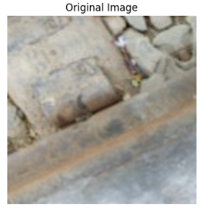 | 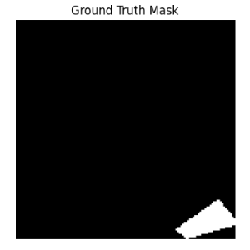 | 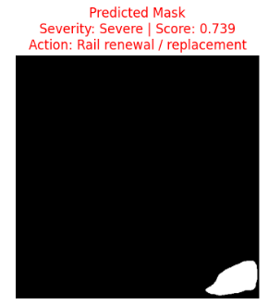
Rail Wear | 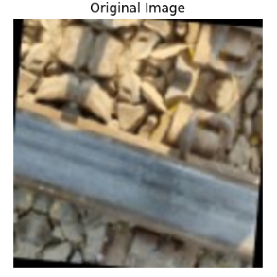 | 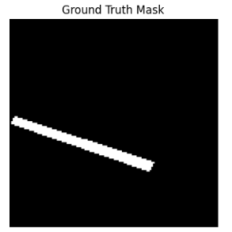 | 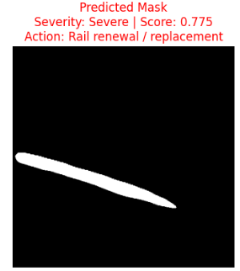
Rail Wear | 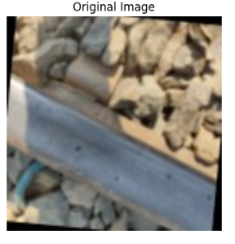 | 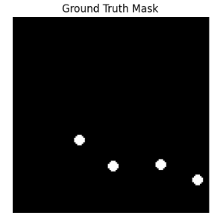 | 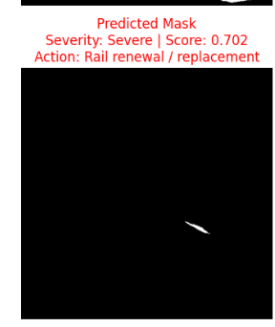
Rail End Batter | 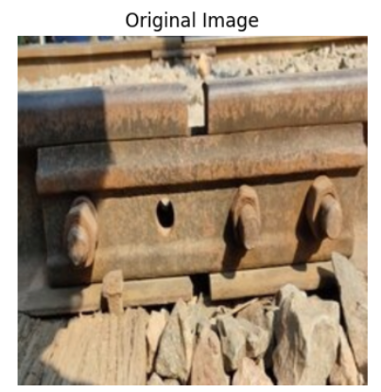 | 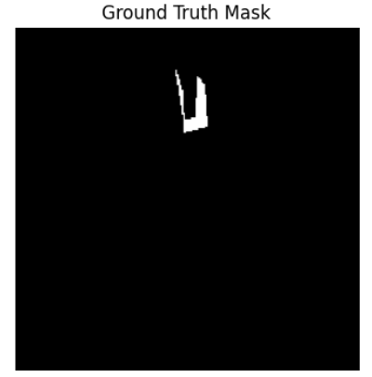 | 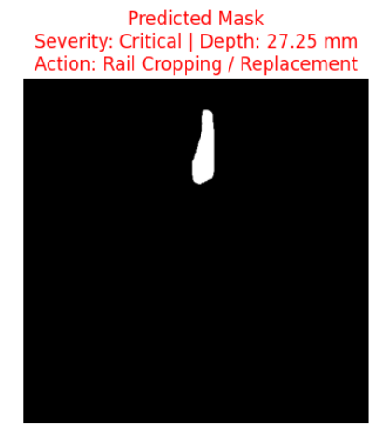
Rail End Batter | 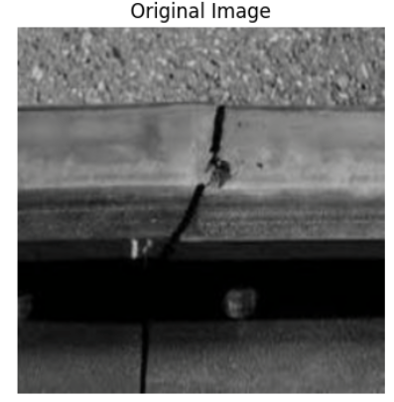 | 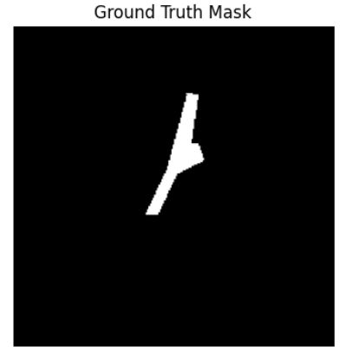 | 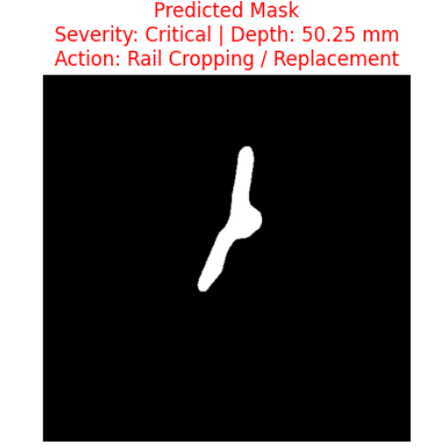
Rail End Batter | 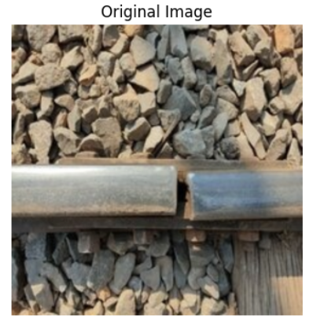 | 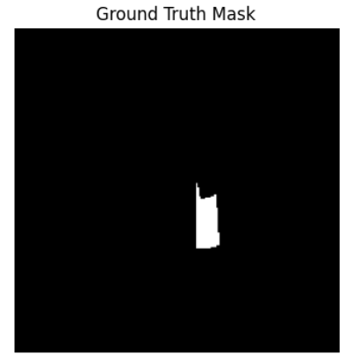 | 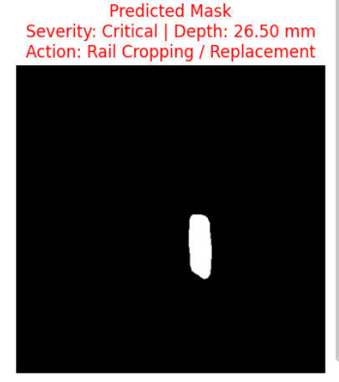

Defect Type | Real Image | Ground Truth Image | UNet++ (EfficientNet B0) Predicted Image  Severity Value  Action Recommended | SegFormer Predicted Image  Severity Value  Action Recommended
Hogging of Rails  214  215  217 | 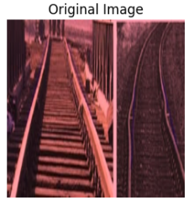 | 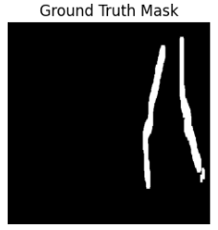 | 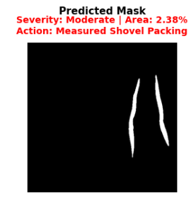
Hogging of Rails  214  215  217 | 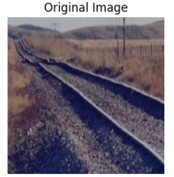 | 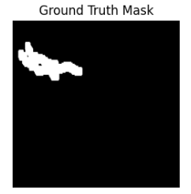 | 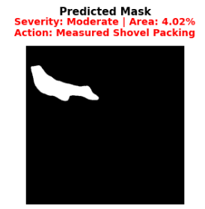
Hogging of Rails  214  215  217 | 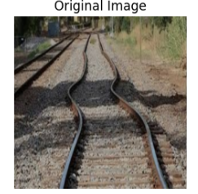 | 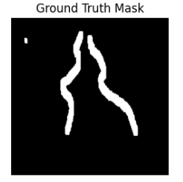 | 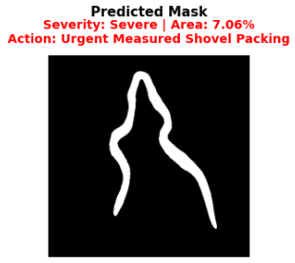
Scabbing of Rails | 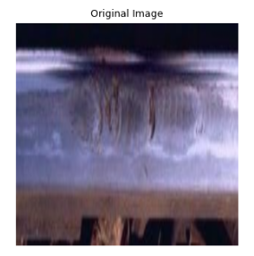 | 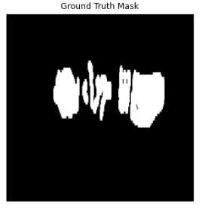 | 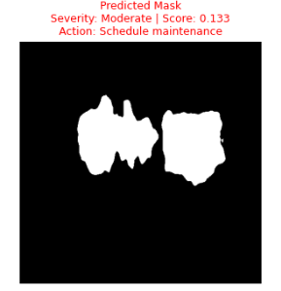
Scabbing of Rails | 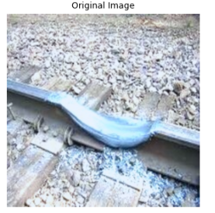 | 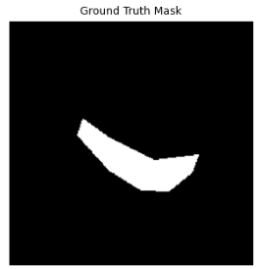 | 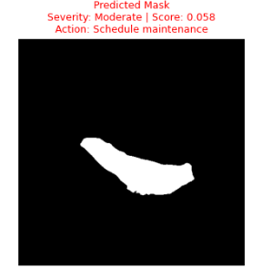
Scabbing of Rails | 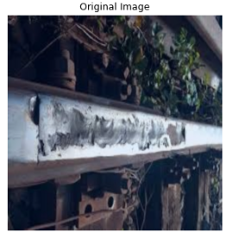 | 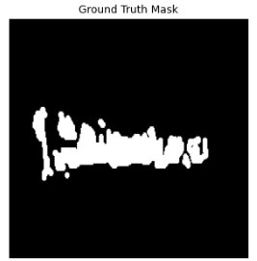 | 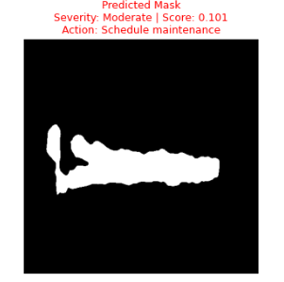

Defect Type | Real Image | Ground Truth Image | UNet++ (EfficientNet B0) Predicted Image  Severity Value  Action Recommended | SegFormer Predicted Image  Severity Value  Action Recommended
Wheel Burns | 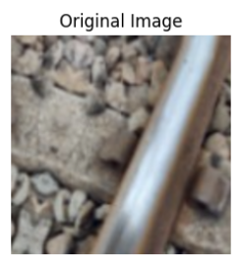 | 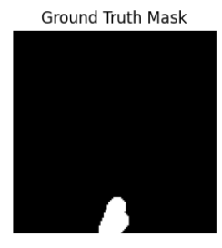 | 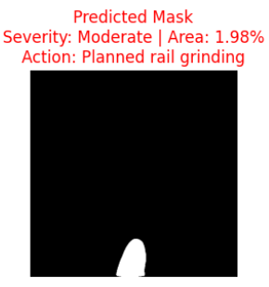
Wheel Burns | 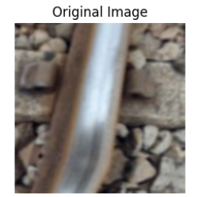 | 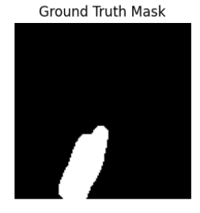 | 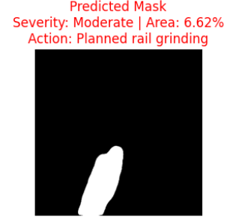
Wheel Burns | 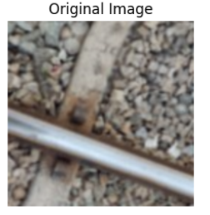 | 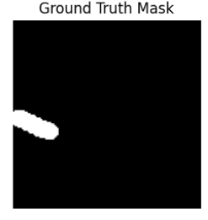 | 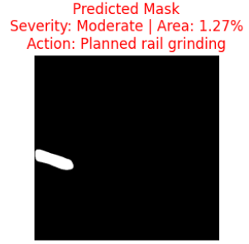
Shelling and Black Spots | 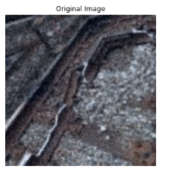 | 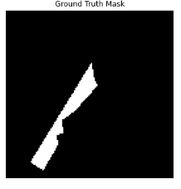 | 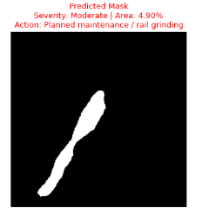
Shelling and Black Spots | 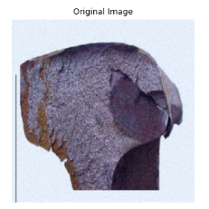 | 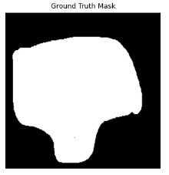 | 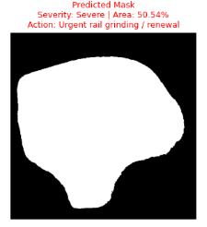
Shelling and Black Spots | 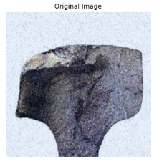 | 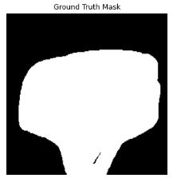 | 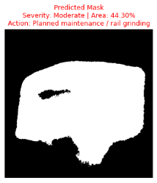

Defect Type | Real Image | Ground Truth Image | UNet++ EficientNet B0 Predicted Image  Severity Score  Action Recommended | SegFormer Predicted Image  Severity Value  Action Recommended
Corrugation of Rails | 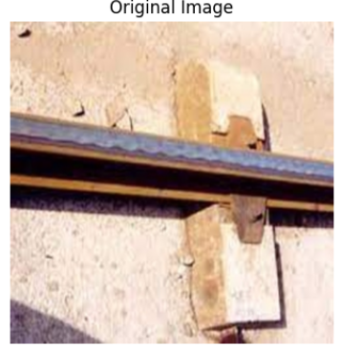 | 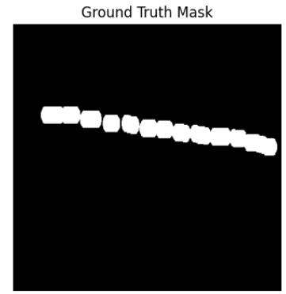 | 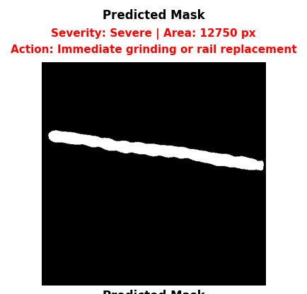
Corrugation of Rails | 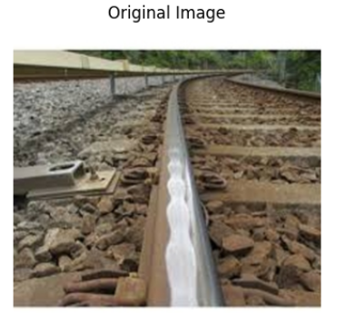 | 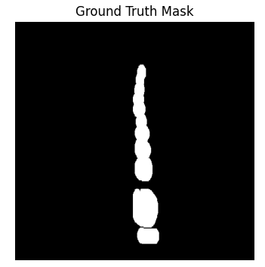 | 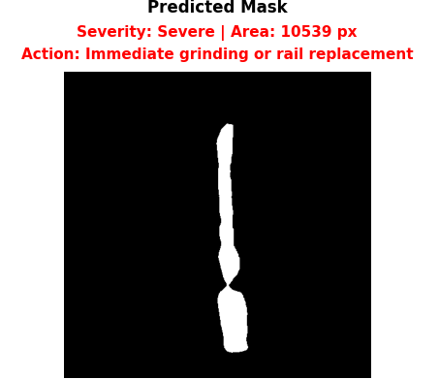
Corrugation of Rails | 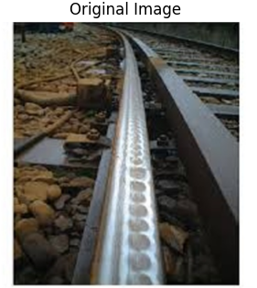 | 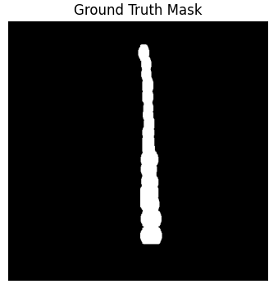 | 

